Unsure how to word your Show/Call submission? Use this guide.

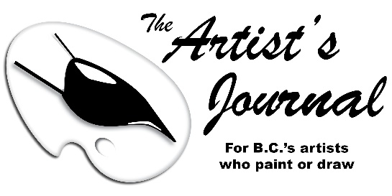
All the information below will be published in your Art Show or Call for Entry news item. Filling out the form below will help me easily edit your news item; therefore, it will be published faster. Also, this form helps you avoid overlooking important information. Thank you!
~ Eve Lees, editor

IMPORTANT: The Artist’s Journal is for artists who paint or draw. Therefore, other art “genres” are not published unless they are held in conjunction with painting & drawing shows & calls.

HOW TO SUBMIT YOUR NEWS ITEM: In the ‘form’ below, fill in your details under each ‘section’ – or create your own written submission, using the form as a guide. Save, then E-mail me this completed form (or your written submission in a Word document) – or you can ‘cut and paste’ the entire form (or your written copy) directly into the message area of your e-mail message.
E-mail it to eve@artnews-healthnews.com There are no submission deadlines: Your news is published a.s.a.p.

Name of Art Show or Call for Entry:

Who can apply if this is a Call for Entry. Please state if this is an open Call to all BC artists or limited to only your area’s artists/members. Also, if applicable, mention ‘non-local’ artists can participate if they pay the membership fee:

Name of the group, gallery, or business organizing / hosting / sponsoring this event:

Date(s) and/or time(s) of the Art Show, or dates &/ times of the Call for Entry’s exhibition (you can include the opening reception if there is one):

Physical street address (including the city) of the event (postal code is not necessary!):

(OR) Web link to the event if it is an online event only:

Type of media (oils, watercolour, etc.,) exhibited in the Art Show or allowed in the Call for Entry:

(OPTIONAL) Theme of the Show or the Call if there is a theme:

(OPTIONAL) Style (abstract, realism, etc.) and subject matter (landscape, still life, etc.) of the artwork to be exhibited in the Art Show or as required in the Call for Entry:

(OPTIONAL) Specific names of participating artists if this is an Art Show (and please double check spellings of names because I am “cutting and pasting,” so errors will be entirely yours!):

(OPTIONAL) Entry fee and membership fee if this is a Call for Entry, or admission fee for Art Show (TIP: in this space, if it applies to your art show, you can write: “No admission fees and free parking”):

(OPTIONAL) Other details you feel are important to include, such as if this is a charity event, if prizes are awarded, etc. (this information may be edited or omitted):

*Submission deadline if this is a Call for Entry (*This is important to include and lets me know when your Call “expires” so that it can be deleted):

A contact e-mail or a web link (or a phone # if nothing else!), for readers to find more detailed information about your Art Show or Call for Entry (this is especially necessary if this is a Call For Entry with an online application form participants must fill out, because The Artist’s Journal will not and cannot include a long, detailed and fillable form within your published news item):

Thank you for submitting your news!

WRITING TIP:
The Artists’ Journal uses the Canadian Press (CP) ‘newspaper’ writing style. CP style is simple, brief, unopinionated wording. Avoid using ‘flowery’ words. For example, “talented artists” or “beautiful paintings” or “We are pleased (or proud) to present,” should be simply “artists” or “paintings” or “presents.” No opinions, just the facts please! This also helps keep your writing short and simple.

